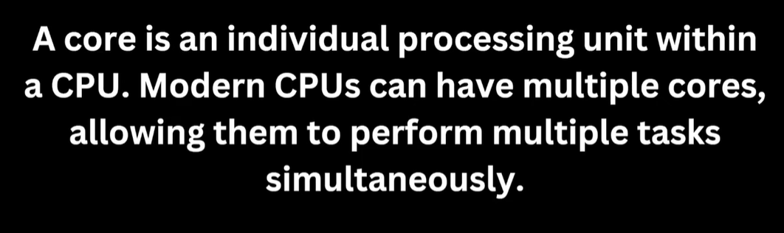

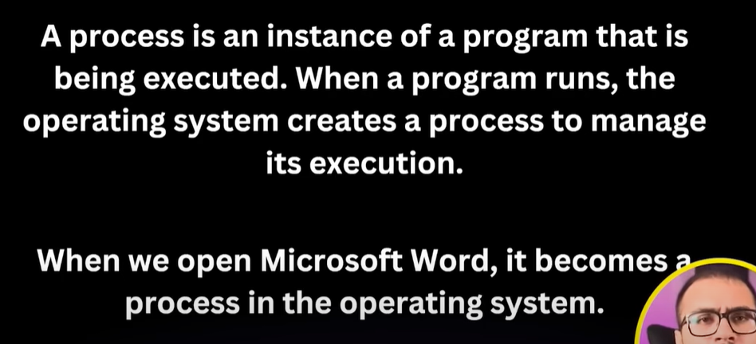

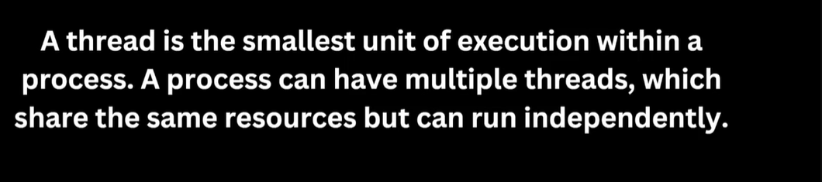

Spell Check, Grammar check, multiple tasks a time on different threads.

You open app that is process and multiple tasks going on background receive messages, send messages, download file, upload file are working on threads.

Threads can work independently. Different browser tabs are working separately.

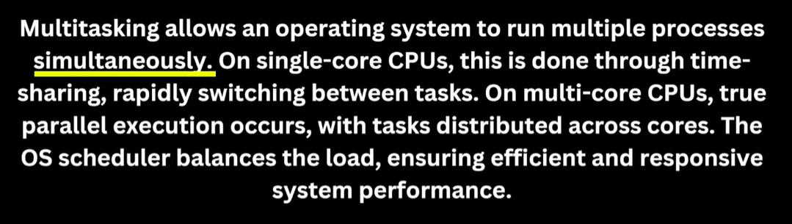

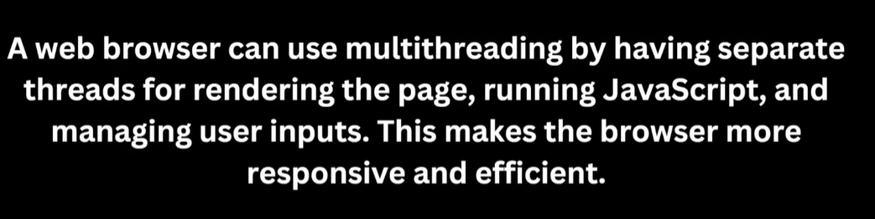

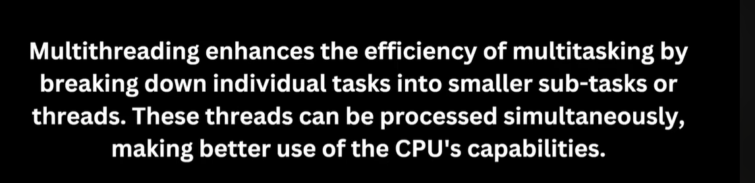

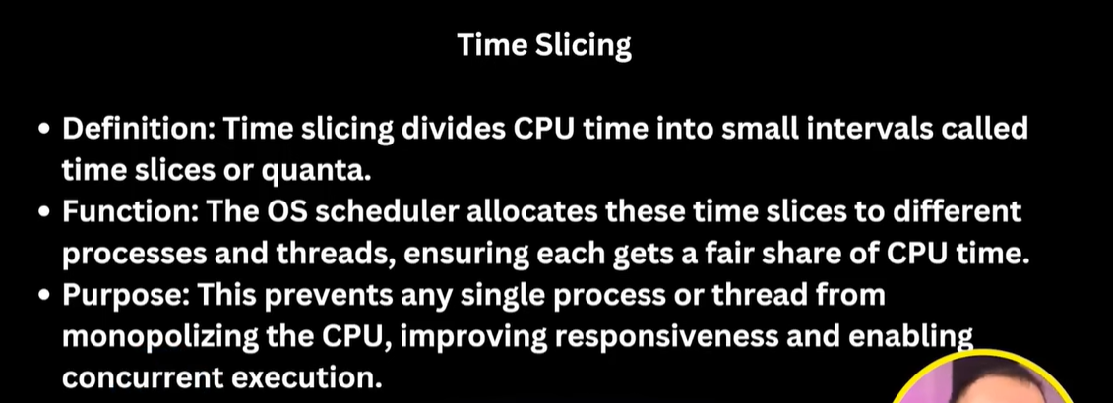

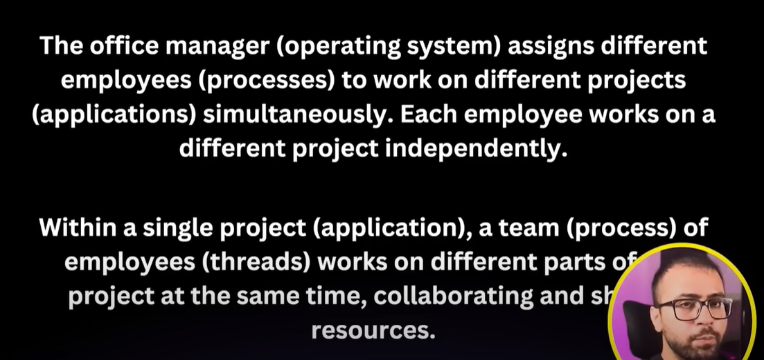

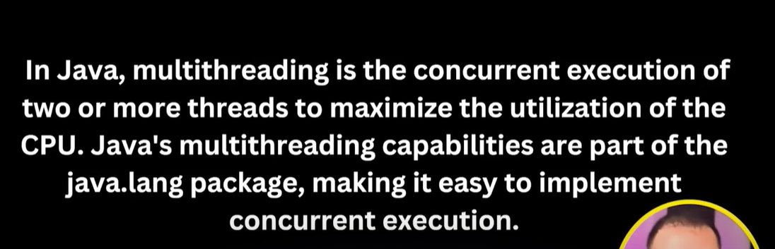

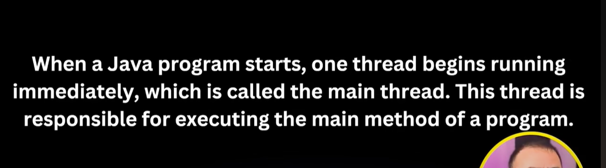

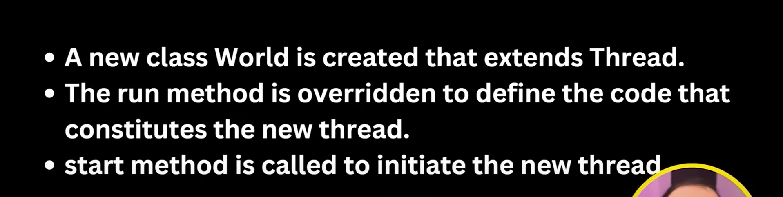

When Implementing Runnable Interface, we need to make thread object of a class who is implementing Runnable interface

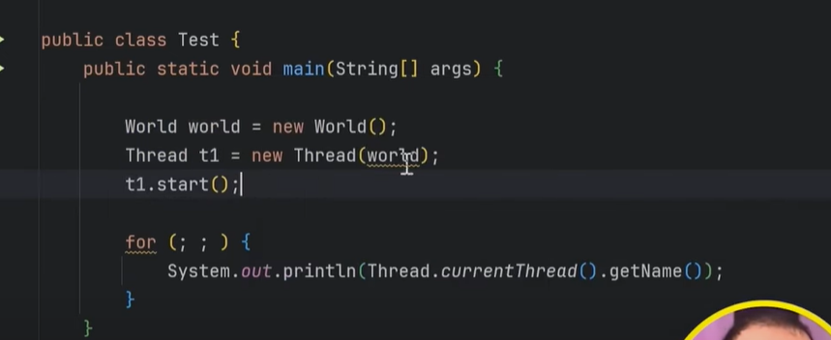

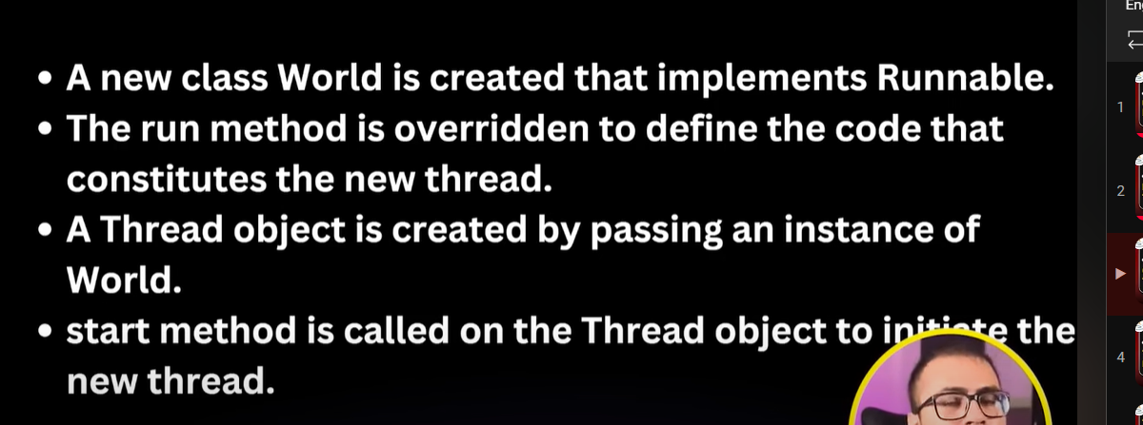

**LIFECYCLE:**

